Brandon Maahs

Stats 587

Homework 7

1.a.

> anova(l.fit)

Analysis of Variance Table

Response: yield

Df Sum Sq Mean Sq F value Pr(>F)

N 3 6461.2 2153.73 4.206 0.02998 \*

Residuals 12 6144.8 512.06

---

Signif. codes: 0 ‘\*\*\*’ 0.001 ‘\*\*’ 0.01 ‘\*’ 0.05 ‘.’ 0.1 ‘ ’ 1

The F statistic is 4.206 with a p-value of 0.02998 and degrees of freedom of 3 and 12. This provides weak evidence against the null hypothesis.

1.b.

pp = pairs(lettuce.emm)

> pp

contrast estimate SE df t.ratio p.value

0 - 50 -29.5 16 12 -1.844 0.3013

0 - 100 -39.0 16 12 -2.437 0.1224

0 - 150 -55.2 16 12 -3.453 0.0215

50 - 100 -9.5 16 12 -0.594 0.9321

50 - 150 -25.8 16 12 -1.609 0.4098

100 - 150 -16.2 16 12 -1.016 0.7438

confint(pp)

contrast estimate SE df lower.CL upper.CL

0 - 50 -29.5 16 12 -77.0 18.01

0 - 100 -39.0 16 12 -86.5 8.51

0 - 150 -55.2 16 12 -102.8 -7.74

50 - 100 -9.5 16 12 -57.0 38.01

50 - 150 -25.8 16 12 -73.3 21.76

100 - 150 -16.2 16 12 -63.8 31.26

Confidence level used: 0.95

Conf-level adjustment: tukey method for comparing a family of 4 estimates

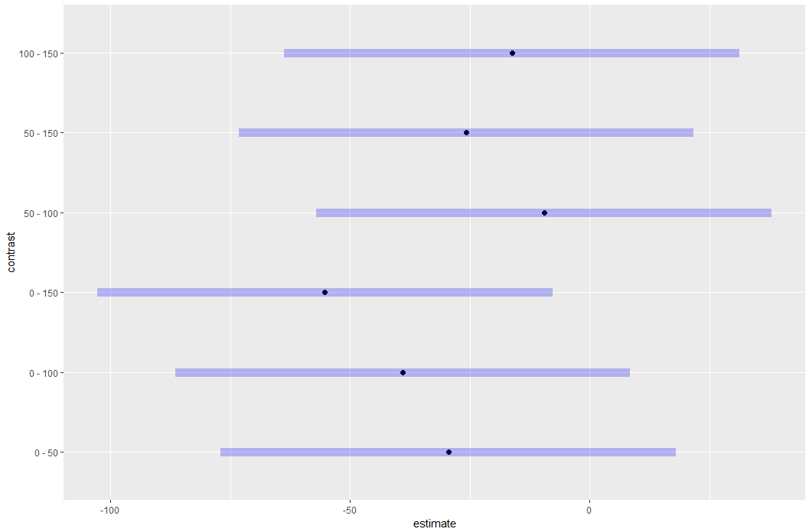

> cld(lettuce.emm, alpha=0.05, Letters=LETTERS)

N emmean SE df lower.CL upper.CL .group

0 108 11.3 12 82.8 132 A

50 137 11.3 12 112.3 162 AB

100 146 11.3 12 121.8 171 AB

150 163 11.3 12 138.1 187 B

Confidence level used: 0.95

P value adjustment: tukey method for comparing a family of 4 estimates

significance level used: alpha = 0.05

1.c.

There is some evidence that adding more fertilizer increases lettuce yield once fertilizer amount reach 150 lb/acre. The only 95% confidence interval which does not encompass zero is the contrast from 0-150. This can also be seen in the plot. The cld also confirms this as 0 and 150 do not share any common letters. However, there is no evidence that the only contrasts with 50 or 100 lb/area of fertilizer increases lettuce yield.

1.d.

contrast(lettuce.emm,list("Linear Trend Contrast"=c(-75,-25,25,75)))

contrast estimate SE df t.ratio p.value

Linear Trend Contrast 4381 1265 12 3.463 0.0047

2.

> cc = contrast(rats.emm, list("A-B"=c(1,-1,0,0,0), "A-C"=c(1,0,-1,0,0), "A-D"=c(1,0,0,-1,0), "A-E"=c(1,0,0,0,-1)), adjust = "bonferroni")

> cc

contrast estimate SE df t.ratio p.value

A-B -0.75 2.69 15 -0.279 1.0000

A-C 7.25 2.69 15 2.694 0.0666

A-D 10.25 2.69 15 3.809 0.0068

A-E -8.50 2.69 15 -3.159 0.0260

P value adjustment: bonferroni method for 4 tests

> confint(cc,level = 0.95)

contrast estimate SE df lower.CL upper.CL

A-B -0.75 2.69 15 -8.383 6.883

A-C 7.25 2.69 15 -0.383 14.883

A-D 10.25 2.69 15 2.617 17.883

A-E -8.50 2.69 15 -16.133 -0.867

Confidence level used: 0.95

Conf-level adjustment: bonferroni method for 4 estimates

Diet D is the only diet that is statistically different that diet A. After adjusting the confidence intervals with the Bonferroni method, the contrast with diet A and D is the only contrast that has confidence intervals not containing zero.

3.a.

> anova(drug.fit)

Analysis of Variance Table

Response: Consumed

Df Sum Sq Mean Sq F value Pr(>F)

Treatment 2 8134.2 4067.1 30.082 6.839e-07 \*\*\*

Residuals 21 2839.2 135.2

---

Signif. codes: 0 ‘\*\*\*’ 0.001 ‘\*\*’ 0.01 ‘\*’ 0.05 ‘.’ 0.1 ‘ ’ 1

Conclusion: With the F statistic being 30.082 and a p-value <0.0001 with 2 and 21 degrees of freedom there is strong evidence that the amount of food consumed by animals in the treatments is not equal.

3.b.

drug.cc = contrast(drug.emm,list( "Saline-drug"=c(1,-0.5,-0.5)))

> drug.cc

contrast estimate SE df t.ratio p.value

Saline-drug 34.8 5.03 21 6.904 <.0001

3.c.

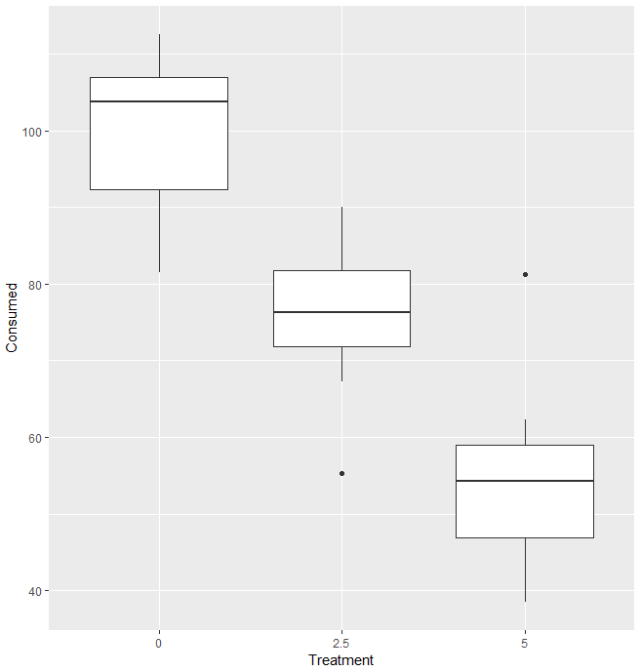

The plot of the means shows the mean consumption rates decreasing as the treatment dosage of the drug increases.

3.d.

> contrast(drug.emm,list("Linear Trend Contrast"=c(23.18,-1.31,-21.86)))

contrast estimate SE df t.ratio p.value

Linear Trend Contrast 1018 131 21 7.762 <.0001

4.a.

Let µ1 and µ4 denote the mean yield of soybean plots treated with treatment A and D respectively.

Ho: µ1= µ4 vs. Ha: µ1≠µ4

MSE= = =9.7bushels/acre

Sp= = = 3.1145 bushels/acre

γ1= µ1+0µ2+0µ3-µ4 = 60.3+ (0x62.1) + (0x57.6) – 52 = 8.3

SE = Sp x $\sqrt{\frac{{coeff}^{2}}{n}+\frac{{coeff}^{2}}{n}+\frac{{coeff}^{2}}{n}+\frac{{coeff}^{2}}{n}}$ = 3.1145 x $\sqrt{\frac{1^{2}}{8}+\frac{0^{2}}{8}+\frac{0^{2}}{8}+\frac{{(-1)}^{2}}{8}}$ = 1.557

T= $\frac{γ1}{SE}$ = $\frac{8.3}{1.557}$ = 5.138 with denominator degrees of freedom of 28

p-value= 0.000019

Conclusion: There is very strong evidence that herbicide A has more of an effect on soybean yield than herbicide D.

95% CI= γ1 + t\* x SE = 8.3 + 2.048 x 1.557 = (5.11, 11.49)

We can be 95% confident that herbicide A will increase mean yield of soybean by 5.11 to 11.49 bushels per acre more than the no herbicide treatment (D).

4.b.

Let µ2 and µ3 denote the mean yield of soybean plots treated with treatment B and C respectively.

Ho: µ2= µ3 vs. Ha: µ2≠µ3

γ2= 0µ1+µ2-µ3+0µ4 = (0x60.3)+ 62.1-57.6+(0x52) = 4.5

T= $\frac{γ2}{SE}$ = $\frac{4.5}{1.557}$ = 2.89 with denominator degrees of freedom of 28

p-value= 0.00736

Conclusion: There is strong evidence that herbicide B has more effect on yield that herbicide C.

95% CI= γ2 + t\* x SE =4.5 + 2.048 x 1.557 = (1.31, 7.69)

We are 95% confident that mean yield of soybean when herbicide B is used is 1.31 to 7.69 bushels per acre more than when herbicide C is used.

4.c.

Let µ5 and µ4 denote the mean yield of soybean plots treated with the average combined effect of treatments A, B and C and effect of treatment D respectively.

Ho: µ5= µ4 vs. Ha: µ5≠µ4

γ3= µ1+µ2+µ3-µ4 = (x60.3)+ (62.1)+($\frac{1}{3}$ 57.6)-52 = 8

SE = 3.1145 x $\sqrt{\frac{{1/3}^{2}}{8}+\frac{{1/3}^{2}}{8}+\frac{{1/3}^{2}}{8}+\frac{1^{2}}{8}}$ = 1.27

T= $\frac{γ3}{SE}$ = $\frac{8}{1.27}$ = 6.292 with denominator degrees of freedom of 28

p-value < 0.0001

Conclusion: There is strong evidence that the mean yield for the herbicide treatments increases compared to the control (no herbicide) treatment.

95% CI= γ3+ t\* x SE =8 + 2.048 x 1.557 = (4.81, 11.19)

We are 95% confident that the combined use of herbicides A, B, and C will increase the mean yield of soybean by 4.81 to 11.19 bushels per acre compared to using no herbicide.

5.a.

> anova(tree.fit)

Analysis of Variance Table

Response: ATP

Df Sum Sq Mean Sq F value Pr(>F)

Group 3 4.5530 1.51766 38.391 1.984e-06 \*\*\*

Residuals 12 0.4744 0.03953

---

Signif. codes: 0 ‘\*\*\*’ 0.001 ‘\*\*’ 0.01 ‘\*’ 0.05 ‘.’ 0.1 ‘ ’ 1

With an F statistic of 38.391, a p-value <0.0001 there is very strong evidence that the ATP concentration is not the same for all four groups.

5.b.

Let µ1 and µ2 denote the mean nmol ATP per mg of tissue in European birch trees in a control and flooding site respectively. Let µ3 and µ4 denote the mean nmol ATP per mg of tissue in river birch tress in control and flooding site respectively.

> tree.emm

Group emmean SE df lower.CL upper.CL

EuropeanControl 1.200 0.0994 12 0.9834 1.417

EuropeanFlooded 0.292 0.0994 12 0.0759 0.509

RiverControl 1.785 0.0994 12 1.5684 2.002

RiverFlooded 1.190 0.0994 12 0.9734 1.407

Confidence level used: 0.95

i. Ho: µ2 = µ1 vs. Ha: µ2≠µ1

> contrast(tree.emm,list("European Control - European Flood"=c(-1,1,0,0)))

contrast estimate SE df t.ratio p.value

European Control - European Flood -0.907 0.141 12 -6.455 <.0001

ii.

> contrast(tree.emm,list("River birch flood - European birch flood"=c(0,1,0,-1)))

contrast estimate SE df t.ratio

River birch flood - European birch flood -0.897 0.141 12 -6.384

p.value

<.0001

iii.

> contrast(tree.emm,list("mean river birch - mean european birch"=c(0.5,0.5,-0.5,-0.5)))

contrast estimate SE df t.ratio

mean river birch - mean European birch -0.741 0.0994 12 -7.456

p.value

<.0001

5.c.

P value adjustment: bonferroni method for 3 tests

> tree.cc

contrast estimate SE df t.ratio p.value

European Control - European Flood -0.907 0.1406 12 -6.455 0.0001

River birch flood - European birch flood -0.897 0.1406 12 -6.384 0.0001

mean river birch - mean european birch -0.741 0.0994 12 -7.456 <.0001

P value adjustment: bonferroni method for 3 tests

> confint(tree.cc, level = 0.95)

contrast estimate SE df lower.CL upper.CL

European Control - European Flood -0.907 0.1406 12 -1.30 -0.517

River birch flood - European birch flood -0.897 0.1406 12 -1.29 -0.507

mean river birch - mean European birch -0.741 0.0994 12 -1.02 -0.465

Confidence level used: 0.95

Conf-level adjustment: bonferroni method for 3 estimates

6.

> beetles.cc = contrast(beetles.emm, list(c(1,0,-1,0),

+ c(1,0,0,-1),

+ c(0,0,1,-1)))

> test(beetles.cc, joint=T)

df1 df2 F.ratio p.value note

2 35 61.065 <.0001 d

d: df1 reduced due to linear dependence

There is very strong evidence against the null hypothesis. There is very strong evidence that the yellow, blue and green colored traps do not all captured the same number of beetles.